# CLASS: F.Y. MCA SEM: I

**COURSE CODE: MC504 SUBJECT NAME: WEB TECHNOLOGY LAB**

# ROLL NO. 2022510059 BATCH: D

**NAME: CHAITANYA SHETTY EXPERIMENT NO: 04**

**EXPERIMENT TITLE:** Write a program using angular to create a calculator.

# Objective:

1. To design Calculator in angular
2. To perform all the operations like addition, subtraction, multiplication, division using it.

# DATE TURN 1: DATE TURN 2:

**PRACTICAL EVALUATION:**

**Marks will be given as Very Good(2), Good(1.5), Average(1) or Poor(0.5).**

|  |  |  |  |  |  |  |
| --- | --- | --- | --- | --- | --- | --- |
| **PI1:**  **Experimental Procedures** | **PI2:**  **Designing skills** | **PI3:**  **Debugging capacity & Efforts taken** | **PI4:**  **Results and Q&A** | **PI5:**  **Lab Ethics** | **Marks Per Experiment** |  |
| **2** | **2** | **2** | **2** | **2** | **10** |  |
|  |  |  |  |  |  |  |

**CODE:**

**app.component.html**

<div class="main">

  <h3>CALCULATOR</h3>

  <p>Number 1<input type = "number" name="num1" [(ngModel)]="num1"> </p>

  <p>Number 2<input type="number" name="num2" [(ngModel)]="num2"> </p>

  <br>

  <button (click)="add()">ADD</button>

  <button (click)="subtract()">SUBTRACT</button>

  <button (click)="multi()">MULTPLICATION</button>

  <button (click)="div()">DIVISION</button>

  <button (click)="clear()">CLEAR</button>

  <h3>Result: <span style="color:rgb(209, 41, 41)">{{num3}} </span></h3>

  </div>

**app.component.css**

.main{

  margin: auto;

  padding: 50px;

  width: 50%;

  text-align:center;

  justify-content: center;

  align-items: center;

  box-shadow: 5in;

  border-color: black;

  background-color: rgb(253, 181, 255);

}

h3{

  font-family: Georgia, 'Times New Roman', Times, serif;

  font-weight: 600;

}

p{

  font-family: Cambria, Cochin, Georgia, Times, 'Times New Roman', serif;

  font-style: italic;

  color: rgb(179, 4, 164);

  font-size: larger;

}

button{

  margin: 5px;

  height: 30px;

  width: 120px;

  color: goldenrod;

  background-color: black;

  border-radius: 15px;

}

button:hover{

  background-color: goldenrod;

  color:black;

  transition: 0.5s;

}

input {

  width: 100px;

  height: 20px;

  border: solid 3px rgb(179, 4, 164);

  margin:20px;

}

span{

}

**App.component.ts**

import { Component } from '@angular/core';

@Component({

  selector: 'app-root',

  templateUrl: './app.component.html',

  styleUrls: ['./app.component.css']

})

export class AppComponent {

  title = 'calculator';

  public num1:number;

  public num2:number;

  public num3:number;

  add(){

    this.num3=this.num1 + this.num2;

  }

  subtract(){

    this.num3=this.num1 - this.num2;

  }

  multi(){

    this.num3=this.num1 * this.num2;

  }

  div(){

    this.num3=this.num1 / this.num2;

  }

  clear(){

    this.num1 = 0;

    this.num2 = 0;

  }

}

**tsconfig.json**

/* To learn more about this file see: https://angular.io/config/tsconfig. */

{

  "compileOnSave": false,

  "compilerOptions": {

    "baseUrl": "./",

    "outDir": "./dist/out-tsc",

    "forceConsistentCasingInFileNames": true,

    "strict": true,

    "noImplicitOverride": true,

    "noPropertyAccessFromIndexSignature": true,

    "noImplicitReturns": false, /* Make this false */

    "strictPropertyInitialization": false,  /* Add This */

    "noFallthroughCasesInSwitch": true,

    "sourceMap": true,

    "declaration": false,

    "downlevelIteration": true,

    "experimentalDecorators": true,

    "moduleResolution": "node",

    "importHelpers": true,

    "target": "ES2022",

    "module": "ES2022",

    "useDefineForClassFields": false,

    "lib": [

      "ES2022",

      "dom"

    ]

  },

  "angularCompilerOptions": {

    "enableI18nLegacyMessageIdFormat": false,

    "strictInjectionParameters": true,

    "strictInputAccessModifiers": true,

    "strictTemplates": true

  }

}

**app.module.ts**

import { NgModule } from '@angular/core';

import { BrowserModule } from '@angular/platform-browser';

import { FormsModule } from '@angular/forms'; /*import this*/

import { AppRoutingModule } from './app-routing.module';

import { AppComponent } from './app.component';

@NgModule({

  declarations: [

    AppComponent

  ],

  imports: [

    BrowserModule,

    AppRoutingModule,

    FormsModule /*add this over here with comma(,)at the end of the previous line*/

  ],

  providers: [],

  bootstrap: [AppComponent]

})

export class AppModule { }

**OUTPUT:**

**ADD**

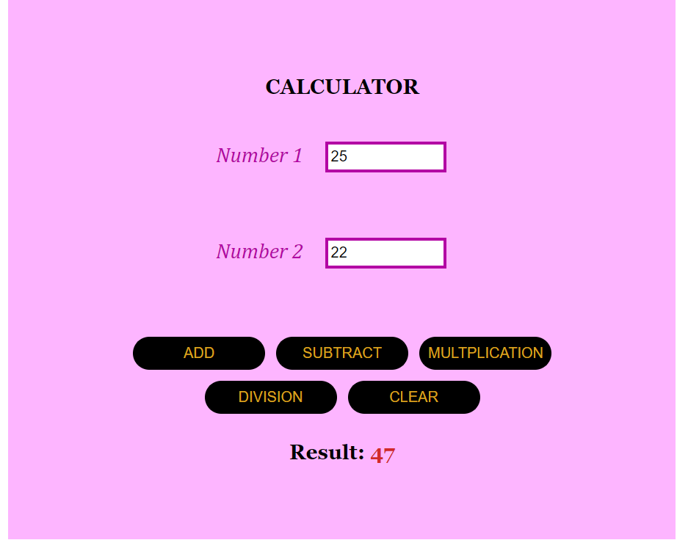

**SUBTRACT**

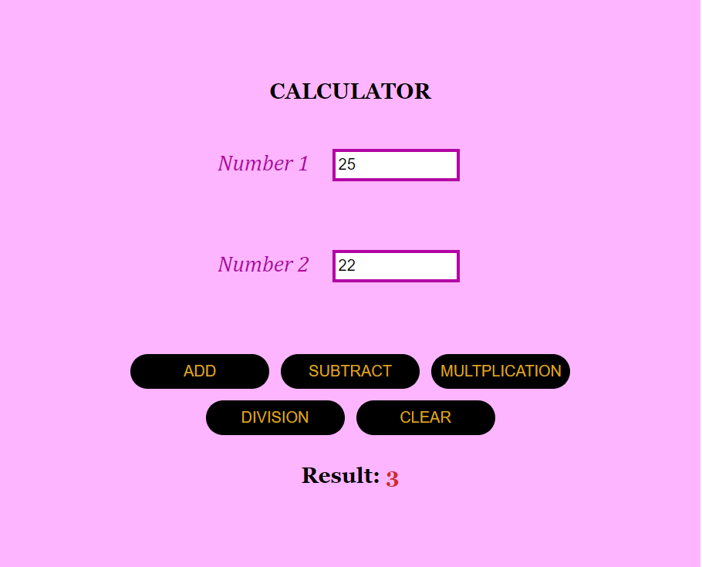

**MULTIPLICATION**

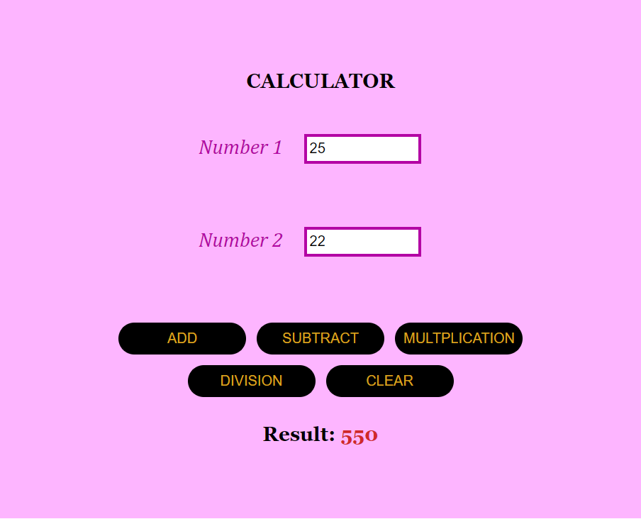

**DIVISION**

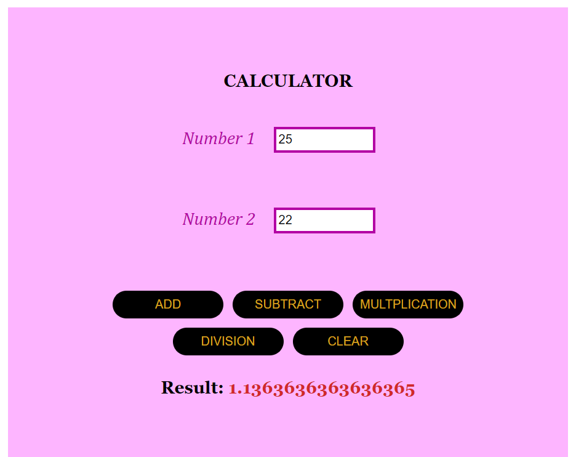

**CLEAR**

